
University of Gondar
Institute of Technology
Department Of Computer Engineering

Real-Time Facial Emotion Detection Desktop Application Using Deep Learning
Prepared by:
1. Abraham Fikre GUR/01153/14
2. Beza Mulugeta GUR/40564/13
3. Ebisa Getachew GUR/23882/13
4. Yilikal Tesfaye GUR/23051/13
Advisor: Amlakie Tazeb

June, 2026
Gondar, Ethiopia

DECLARATION
We, the students whom worked on this project and paper, are students at the University of Gondar, Department of Computer Engineering. We declare that this thesis paper and the project which it encompass is our own original work. It has not been submitted or presented before any evaluation or submission at any other University, and all sources of material used for the project work as well as this paper will be fully acknowledged.

Name of students Date Signature
- Abraham Fikre -----/------/----------- ------------
- Beza Mulugeta -----/------/----------- ------------
- Ebisa Getachew -----/------/----------- ------------
- Yilikal Tesfaye -----/------/----------- ------------

APPROVAL
Approval template task: find this

ACKNOWLEDGMENT

ABSTRACT

TABLE OF CONTENT
DECLARATION I
APPROVAL II
ACKNOWLEDGMENT III
ABSTRACT IV
TABLE OF CONTENT V
LIST OF FIGURES VIII
LIST OF TABLES IX
LIST OF ABBREVIATIONS X
CHAPTER ONE: INTRODUCTION 1
1.1 Background of the Study 1
1.2 Statement of the Problem 3
1.3 Research Questions 3
1.4 Objectives 4
1.4.1 General Objective 4
1.4.2 Specific Objectives 4
1.5 Scope of the Study 5
1.5.1 Functional Scope 5
1.5.2 Technical Scope 5
1.5.3 Project Limitations 6
1.6 Significance of the Study 6
1.7 Contribution of the Study 6
1.8 Organization of the Thesis 6
CHAPTER TWO: LITERATURE REVIEW 7
2.1 Introduction 7
2.2 Emotion and Emotion Theories 7
2.3 Facial Emotion Recognition 8
2.4 Computer Vision for Face Analysis 10
2.5 Deep Learning 10
2.6 Transfer Learning 11
2.7 Knowledge Distillation 11
2.8 Model Optimization Techniques 11
2.9 ONNX and Model Deployment 11
2.10 Desktop FER Systems 12
2.11 Related Works 12
2.12 Research Gap 12
2.13 Conceptual Framework 12
CHAPTER THREE: METHODOLOGY 13
3.1 Introduction 13
3.2 Research Design 13
3.3 System Overview 14
3.4 Dataset Development 15
3.4.1 Dataset Sources 15
3.4.2 Data Preprocessing 16
3.4.2.1 Dataset Loading and Filtering 17
3.4.2.2 Face Detection and Face region Extraction 17
3.4.2.3 Face Alignment 17
3.4.2.4 Face Cropping 17
3.4.2.5 Image Cleaning and Normalization 18
3.4.2.6 Data Augmentation and Image Resizing 18
3.6 Model Evolution 19
3.6.1 Model Version 1 19
3.6.2 Model Version 2 20
3.6.3 Model Version 3 22
3.6.4 Model Version 4 24
3.6.5 Model Version 5 26
3.6.6 Model Version 6 28
3.7 Desktop Application Specification 30
3.8 Face Detection Evolution 30
CHAPTER FOUR: RESULTS AND DISCUSSION 31
4.1 Experimental Setup 32
4.1.1 Hardware Environment 32
4.1.2 Software Environment 32
4.1.3 Training Configuration 33
4.1.4 Summary of Experimental Design 33
4.2 Dataset Statistics 34
4.2.1 Dataset Description 34
4.2.2 Class Distribution 34
4.2.3 Data Preprocessing and Augmentation 35
4.2.4 Dataset Split 36
4.2.5 Sample Images per Class 36
4.3 Model Comparison 37
4.3.1 Performance Trend Analysis 37
4.3.2 Key Observations 38
4.3.3 Final Model Selection Justification 39
4.4 Training Analysis 40
4.4.1 Training Loss Behavior 40
4.4.2 Validation Accuracy Behavior 41
4.4.3 Convergence Analysis 42
4.4.4 Loss vs Accuracy Relationship 42
4.5 Confusion Matrix Analysis 42
4.5.1 Overall Confusion Matrix 42
4.5.2 Class-wise Performance Analysis 44
4.6 Knowledge Distillation Analysis 44
4.6.1 Teacher–Student Framework Overview 45
4.6.2 Knowledge Transfer Mechanism 45
4.6.3 Teacher vs Student Performance Comparison 45
4.6.4 Performance Improvement Due to Distillation 46
4.6.5 Feature Alignment Effect 47
4.7 Application Evaluation 47
4.7.1 Webcam-Based Emotion Recognition 47
4.7.2 Image Upload Performance 48
4.7.3 Real-Time Inference Efficiency 49
4.7.4 Resource Utilization 50
4.8 Deployment Analysis 50
4.8.1 Model Export to ONNX 51
4.8.2 Deployment Pipeline 52
4.8.3 Inference Optimization 52
4.8.4 Speed Improvement Analysis 53
4.9 Contribution Validation 53
4.9.1 Contribution 1 — Lightweight Yet Accurate Emotion Recognition Model 53
4.9.2 Contribution 2 — Improved Knowledge Distillation Framework 53
4.9.3 Contribution 3 — Reliable Training Strategy with EMA 54
4.9.4 Contribution 4 — Efficient Deployment Using ONNX 54
4.10 Discussion 54
4.10.1 Performance Evolution Across Models (V1–V6) 54
4.10.2 Why V4 Performance Dropped 55
4.10.3 Key Factors Behind Performance Improvement 55
4.10.4 Why V6 Achieved the Best Performance 56
4.10.5 Overall Research Insight 56
4.10.6 Final Justification of Model Selection 56
CHAPTER FIVE: CONCLUSION AND FUTURE WORK 57
5.1 Conclusion 57
5.2 Limitations 57
5.3 Recommendations 57
5.4 Future Work 57
REFERENCES 58
APPENDICES 60
APPENDIX A: Application Interfaces 60
APPENDIX B: User Manual 60

LIST OF FIGURES
Figure 1.1: The Contextual Inverted Pyramid of the Study Framework. 2
Figure 2.1: Seven Emotion Categories 8
Figure 3: Operational Conceptual Framework Data Flow Diagram. 12

LIST OF TABLES
Table 1: Mapping of Core Engineering Problems to Objectives and Technical Resolutions. 4

LIST OF ABBREVIATIONS
B.Sc.
AI
CPU
GPU
FER
QThread

CHAPTER ONE: INTRODUCTION

1.1 Background of the Study
Throughout history, humans have relied on multiple ways of communication to express their thought, their internal states and the social intentions they might have. This exchange can happen in multiple way, including spoken language, body posture and gestures. Even though speech allows for clear communication, non-speech or what we might call non-verbal carry some amount of insight and meaning in people’s interaction. Among non-verbal ways of communicating, facial expressions are the most informative, that displays emotional shifts without the need of spoken words.
Understanding these emotional shifts is important because emotions serves as the driver of human behavior, decision-making tasks, everyday performance and social activities. According to the Marriam-Webster dictionary, emotion is a conscious mental reaction subjectively experienced as strong feeling usually directed toward a specific object and typically accompanied by physiological and behavioral changes in the body. In other words, emotions prepare us to deal with important events without having to think about them.
Consequently, emotion have multiple vital roles in our daily lives. It can be in education, workplace, healthcare and also in human-computer interaction. Within the education environment, noticing students’ emotional responses allows teachers to identify boredom, confusion or satisfaction in the classroom, which enables adaptive guidance. In the workplace, emotional cues can help evaluate employee burnout, job satisfaction and interpersonal settings. For healthcare, monitoring facial expressions help medical professionals in assessing patient distress and in some cases neurological conditions. Finally, in human-computer interaction, implementing emotional awareness into programs allows software to shift to an empathetic system that are capable of responding directly to user frustration or any emotional cues.
To implement this observational process and replicate these human capabilities within the digital world, computer scientists and engineering are using the power of Artificial Intelligence(AI). AI is technology that enables computers and machines to simulate human learning, comprehension, problem solving, decision making, creativity and autonomy. [1] Within the applications of AI, Computer Vision operates as a specialized field that equips machines with the ability to process, analyze and interpret visual inputs such as digital images and videos. Through Deep learning and computer vision algorithms, systems can be created that can recognize facial emotion.
Developing these Frameworks into real-time desktop software allows for continuous video processing, but local deployment on consumer machines such as low-laptops present unavoidable hardware limitations. High-accuracy deep-learning networks are computationally heavy and they usually require cloud-hosted GPUs, also they create great latency when run locally on a standard desktop CPUs. Additionally, in localized environments where continuous, high-speed internet is unavailable and also costly, thus cloud-dependent processing is impractical. This projects addresses these constraints by using model compression techniques to build a light weight, fully offline, real-time desktop FER application that can be used in standard consumer hardware.

1.2 Statement of the Problem
Despite the importance of emotional states in daily life, there is no widely adopted system for consistent, real-time emotion analysis in professional or educational environments. Existing tools are either limited to research settings or require specialized hardware. Manual observation is subjective and prone to bias, while surveys and questionnaires cannot capture dynamic emotional changes. This gap highlights the need for an accessible, real-time emotion detection system that can operate on standard desktop environments using readily available webcams. Such a system would provide valuable insights into emotional states without replacing human judgment, serving as a supportive tool for educators, employers, and mental health professionals.

1.3 Objectives

1.3.1 General Objective
- To design and implement a real-time desktop application capable of identifying human facial emotions while running efficiently on low-end computers

1.3.2 Specific Objectives
- To design and implement a real-time desktop application for facial emotion detection that capture real-time video frames from a webcam.
- To preprocess, and merge multiple public facial expression datasets for seven-class emotion recognition.
- To train and evaluate an emotion recognition model that classifies 7 emotions that are happy, sad, anger, surprise, disgust, fear, and neutral.
- To integrate the trained emotion recognition model into a real-time desktop interface.
- To display facial emotion predictions and confidence scores on live video.

1.4 Scope of the Study
The project focuses on the development of a desktop application for real-time facial emotion detection using PySide and Deep learning. It captures live video feed from a laptop webcam, perform face detection and preprocessing then classification into seven emotion categories: Happiness, Sadness, Anger, Fear, Surprise, Disgust, and Neutrality. The model will be optimized to run on CPU-only environments, ensuring it remains functional on standard Core i3/i5 laptops without dedicated GPUs. In addition, the graphical dashboard built with PySide6 will display the live video overlay, emotion labels, and real-time confidence scores (percentages).
The project is not meant to perform multi-face tracking across massive crowds simultaneously. It does not focus on cloud-based client server deployment or training massive models from scratch on the local edge device itself.

1.5 Significance of the Study
- Increased Accessibility of Visual AI: By optimizing the model to run efficiently on standard, low-spec CPU processors, the application makes advanced computer vision accessible to resource-constrained environments (like schools, public labs, and small clinics) that cannot afford expensive GPU hardware.
- Complete Data Privacy: Because the application runs entirely offline and processes all video data locally on the host machine, it guarantees absolute data privacy. This makes it safe for sensitive use cases like tracking student engagement or observing clinical patients, where transmitting video data over the internet is a major security risk.
- Software Engineering Pattern: It provides developer communities with a blueprint for building lightweight deep learning applications, proving that models can be deployed cleanly without heavy training dependencies.

1.6 Contribution of the Study
- Developed a lightweight yet accurate emotion recognition Model
- Improved Upon Knowledge Distillation Framework
- Structured a reliable training strategy with Exponential Moving Average
- Efficient Deployment Using ONNX

1.6 Conceptual Framework

CHAPTER TWO: LITERATURE REVIEW

2.1 Introduction
This Chapter reviews existing literature on emotion itself, facial emotion recognition, computer vision, deep learning, transfer learning, knowledge distillation and related technologies to establish the theoretical framework and contextualize the proposed Real-time facial emotion detection application. It also explores model optimization techniques, ONNX and model deployment and desktop FER systems. Beyond that it identifies the current state of implementation and the existing research gap between them all.

2.2 Emotion and Emotion Theories
Emotions are a process, a particular kind of automatic appraisal influenced by our evolutionary and personal past, in which we sense that something important to our welfare is occurring, and a set of psychological changes and emotional behaviors begins to deal with the situation. [2] Of all the human emotions we experience, there are seven universal emotions that we all feel, transcending language, regional, cultural, and ethnic differences.
Each of the universal emotions has distinctive signals, physiologies and timelines. While they vary in their onset duration and decline, emotions typically don’t last longer than an hour. If an emotion persists for an extended amount of time without interruption, it’s more likely that the emotion can be categorized as a mood or a disorder.
The universal emotions includes
- Anger
- Contempt
- Disgust
- Enjoyment
- Fear
- Sadness
- Surprise

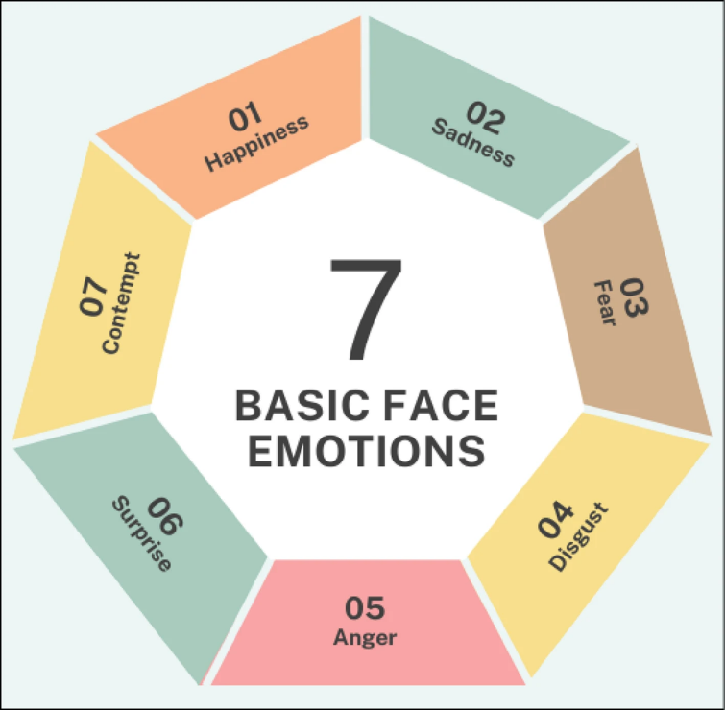
2.3 Facial Emotion Recognition
Figure 2.1: Seven Emotion Categories from Source [5]
Recognizing emotions through facial expressions is essential to human connection and communication. To grasp social cues, empathize with others, and make wise decisions in a variety of interpersonal circumstances. One of the main ways people express their emotions non-verbally is through facial expression, in which they reflect a wide range of emotions, including joy, sadness, anger, fear, surprise and disgust, among others, though minor, variations in their facial muscle movements. These behaviors work as potent indicators of an individual’s affective state, conveying important details about their intentions, emotions, and responses to inputs from the outside world [3].
Facial Emotion Recognition (FER) is the technology that analyses facial expressions from both static images and videos in order to reveal information on one’s emotional state [4]. The first days of artificial neural network research began with the Perceptron model in the 1950s and advanced to the multilateral network with the introduction of the backpropagation method in the 1980s, where deep learning began. As a separate word, however, intensive learning, which only describes nervous network training on several levels, has come much later. In the Facial Expression Recognition field (FER), models such as recurrent neural networks (RNNS) and CNN, such as the end of the 2000s, and models as traditional machine learning from traditional machine learning methods to learn deeply according to traditional machine learning methods. These models greatly improved learning by allowing automated recovery of hierarchical representatives from facial images and videos. [5]
Facial emotion recognition (FER) has advanced significantly, and deep learning-based models have supplanted traditional feature extraction techniques [5]. The emergence of deep learning (DL), which provides significant improvement of traditional machine learning methods, has revolutionized facial expression recognition (FER). Unlike the previous FER methods, which manually depend on functional extraction produced, the deep learning models automatically extract the complex Hiezen features from raw face images. This round has improved accuracy, flexibility and adaptability, which is an essential tool in image identity, natural language processing (NLP), speech recognition and emotional data processing [5].
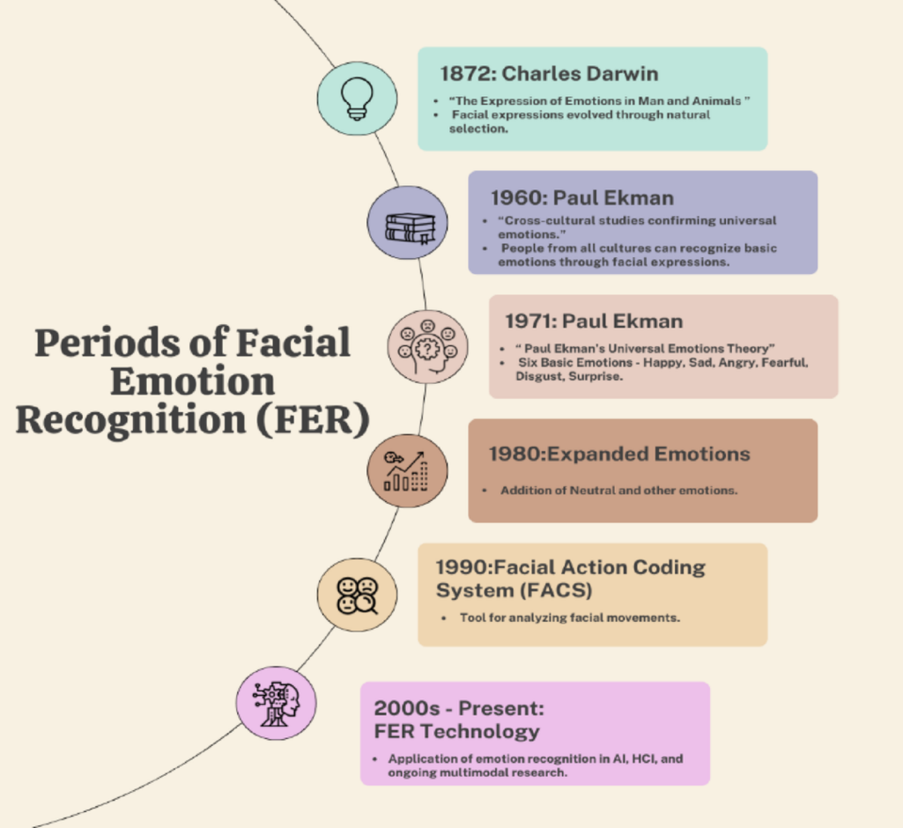
Figure 2.2 shows the periods of Facial Emotion Recognition (FER) throughout its advancements and history.
Figure 2.2 Periods of Facial Emotion Recognition(FER) from source [5]

2.4 Computer Vision for Face Analysis
Face detection has been an attractive topic in computer vision for decades. It is heavily dependent as a pre-requisite step for many face-related applications such as face recognition, face beautification, face alignment, face tracking, etc. Given an image, face detection locates the face regions by bounding boxes. Many methods have been proposed to improve face detection performance, from early hand-crafted features such as Haar cascade to current CNN-based features [6].
Historically, classical face detection relied on the Haar Cascade technique introduced by Viola and Jones in 2001. A Haar wavelet is a mathematical concept that produces square-shaped waves with a distinct beginning and end, which are used to construct box-shaped patterns to recognize visual signals with sudden transformations. By combining several wavelets, a cascade of classifiers is formed to identify edges, lines, and circular structures across differing color intensities. [7]
To analyze an input frame using Haar cascades, a window scale is selected that is smaller than the target image. This window slides across the pixel grid, calculating the average pixel intensity values within adjacent rectangular sections. If the numerical difference between these section averages surpasses a predefined mathematical threshold, it is registered as a structural match. For human subjects, face detection is achieved by finding a specific combination of these diverse Haar-like features (such as the contrast between the eye region and the bridge of the nose). While computationally fast, Haar cascades are notoriously fragile when subjected to real-world variations like head tilts, side profiles, or poor lighting conditions. [7]
Currently for face analysis, other detection method are used utilizing deep learning for isolating parameters visible in human face. One of these detection method is by using YuNet model. YuNet is a highly efficient face detection model. With only 75k parameters, it is designed to operate with minimal computational resources while maintaining exceptional balance between accuracy and speed, making it ideal for real-time applications on edge devices [8]. YuNet has a higher degree of detecting faces than Haar Cascade. Issues found in Haar Cascade like head tilts, poor lighting condition affects YuNet in a lower manner, thus making YuNet the better solution for face detection under the field of computer vision.

2.5 Deep Learning
Deep learning is a subset of machine learning driven by multilayered neural networks whose design is inspired by the structure of the human brain. Deep learning models power most state-of-the-art artificial intelligence (AI) today, from computer vision and generative AI to self-driving cars and robotics [9].
Deep learning approaches have significantly advanced the state-of-the-art in FER in recent years, Their exceptional capacity to extract intricate spatiotemporal characteristics from images of face. Nonetheless, there remains a compelling need to improve such systems' precision and computational effectiveness, especially in scenarios involving real-time or large-scale deployments [10].

2.6 Transfer Learning
Transfer learning is a machine learning technique in which knowledge gained through one task or dataset is used to improve model performance on another related task or different dataset. In other words, transfer learning uses what has been learned in one setting to improve generalization in another setting. [11]
Transfer learning algorithms takes already-trained models or networks as a starting point. It then applies that model’s knowledge gained in an initial source task or data (e.g. classifying faces) towards a new, yet related, target task or data (e.g. classifying facial emotion) [11].
Transfer learning techniques are used for facial emotion recognition for the reason of mitigating dataset scarcity, accelerating network convergence, and drastically reducing the computational resource overhead required to train high-accuracy deep models from scratch.

2.7 Knowledge Distillation
Knowledge distillation is a machine learning technique that aims to transfer the learnings of a large pre-trained model, the “teacher model,” to a smaller “student model.” It’s used in deep learning as a form of model compression and knowledge transfer, particularly for massive deep neural networks. The goal of knowledge distillation is to train a more compact model to mimic a larger, more complex model. Whereas the objective in conventional deep learning is to train an artificial neural network to bring its predictions closer to the output examples provided in a training data set, the primary objective in distilling knowledge is to train the student network to match the predictions made by the teacher network. [12]

2.8 Model Optimization Techniques

2.9 ONNX and Model Deployment

2.10 Desktop FER Systems

2.11 Related Works

2.12 Research Gap

CHAPTER THREE: METHODOLOGY

3.1 Introduction
This chapter details the technical methodology used to design, train, and deploy an edge-optimized real-time facial expression recognition (FER) system. The core focus of this design is to resolve the high computational and memory demands typical of modern deep convolutional neural networks, making the system viable for low-latency desktop execution. This is achieved by combining advanced cross-resolution knowledge distillation with a fast deep-learning face localization framework.

3.2 Research Design
This study adopts an iterative engineering design methodology, focusing on continuous optimization loops to systematically improve accuracy while keeping the inference footprint small. Rather than relying on a static, single-shot training setup, the project progressed through an evolutionary sequence of architectural experiments. Each developmental phase acted as an engineering baseline where structural bottlenecks—such as representational compression losses, model underfitting caused by aggressive augmentations, and severe class imbalances were isolated, evaluated under heavy training stress, and iteratively resolved.
Earlier phases of the research explored different compression boundaries, varying student backbone capacities, and alternative localization frameworks like Haar Cascade classifiers. However, these introductory configurations struggled to balance low latency with structural stability under aggressive data augmentations. The research design therefore culminated in a dual-stream knowledge distillation framework that balances task-specific label-smoothed Focal Loss, soft logit matching, and intermediate feature-map alignment. This final iteration successfully retains high-fidelity geometric facial features within a lightweight, production-ready runtime model.
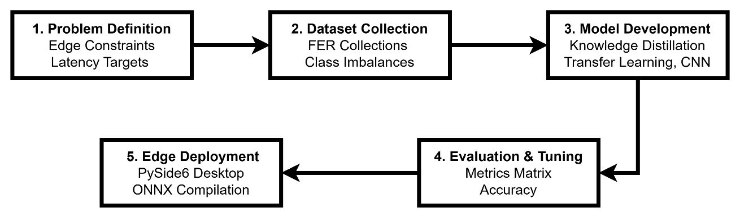
The engineering timeline moves through these structured stages:
- Problem Definition: Establishing target deployment parameters, including low-latency execution targets and hardware-independent CPU runtime compatibility.
- Dataset Collection and Augmentation: Bundling multi-source facial expression images and applying aggressive stochastic augmentations to handle illumination shifts and alignment anomalies.
- Model Development: Transitioning through multiple evaluation configurations to arrive at the final dual-stream knowledge distillation framework. This setup leverages cross-resolution data from a high-resolution frozen ConvNeXt-Small teacher to optimize an upgraded EfficientNetV2-S student core.
- Evaluation: Assessing performance across developmental iterations using balanced accuracy, macro F1-scores, memory footprint overhead, and real-time frames-per-second (FPS) throughput metrics.
- Deployment: Compiling the finalized, highest-performing model weights into a static ONNX runtime execution graph and embedding it inside a non-blocking desktop user interface.

3.3 System Overview
The complete system architecture functions as an end-to-end data processing pipeline that maps input pixel arrays to smoothed categorical expression outputs. The application isolates user interface rendering from heavy computer vision inference by executing tasks on decoupled processing layers, ensuring the system remains responsive.
The complete real-time operational pipeline is diagrammed below in Figure 3.2.
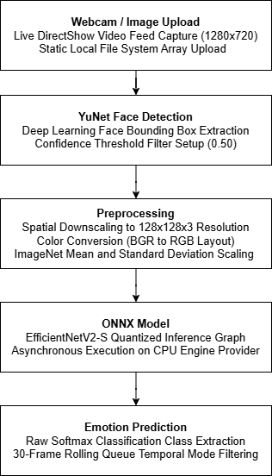
The system execution maps directly across these integrated layers:
- Input Interface Engine: The pipeline ingests raw graphic data either through a continuous camera frame stream using the hardware's native capture channel or via a static image file pulled from the local file system.
- Localization Layer: The matrix is parsed by YuNet, an open-source deep learning face detector, which identifies coordinates and isolates the face bounding box slice while removing irrelevant background noise.
- Array Normalization Pipeline: The isolated face slice undergoes fixed geometric preprocessing, reshaping the matrix to a standard channel-first tensor matching the exact format expected by the model.
- Graph Execution Engine: The normalized tensor is passed to a compiled ONNX Runtime environment where the knowledge-distilled student model processes the forward-pass calculations.
- Post-Processing Filter: The raw probability scores are calculated, and streaming outputs are stabilized through a 30-frame temporal rolling queue to prevent label flickering.
- Interface Render Layer: The final predicted emotion class and confidence score are updated on the PySide6 user interface components, while a custom log handler pipes tracking metrics directly to the system console footer.

3.4 Dataset Development
In machine learning, dataset is the foundation upon which the entire model development process is built. This is because it provides the information through which a model learns recognizing of patterns and understand real world scenario. Hence, the characteristics of the dataset have direct impact on the performance and reliability. To address these, various factors should be considered including dataset size, diversity, domain coverage, subject independence and dataset bias.

3.4.1 Dataset Sources
There are several dataset sources such as public research dataset, web scraped or custom collected. This project uses an image dataset collection that was obtained from multiple publicly available resources arranged in a unified emotion-wise directory structure. These sources were selected considering three important aspects: ethical reasons, practical reasons, scientific reproducibility. Since facial emotion data involves human faces, it raises ethical considerations related to privacy, consent and data usage. To address these concerns, publicly available datasets was used in the project since the research datasets have been obtained with the consent of the subjects and already undergone through ethical review processes ensuring to minimize the unnecessary ethical risks. Building a dataset from scratch is extremely expensive in terms of time, effort, ethics and finance as it is needed to collect more than thousands of images. Using public datasets also ensures for results can be compared with other papers and experiments are reproducible allowing fair comparison across experiments.
The datasets adopted in this project are summarized in the table
Dataset | Description
CK+ (Extended Cohn–Kanade) | A laboratory-controlled dataset containing about 600 images with clean backgrounds
KDEF (Karolinska Directed Emotional Faces) | A collection of 4900 images from 70 subjects with balanced representation of male and female participants wearing standardized clothing
FER2013 | Containing about 35,000 grayscale, low resolution images obtained from diverse sources
RAF‑DB | A real-world dataset containing images with varied poses, occlusion and lighting condition
AffectNet | One of the largest facial datasets with approximately 300,000 images with wide variability in demographics and environment.
FER2024 | A subject-organized dataset designed for modern FER research bridging laboratory and real-world data
Custom Dataset | A dataset with clear facial emotion expressions

3.4.2 Data Preprocessing
Dataset preprocessing is a crucial stage because raw data is not suitable for the model to learn from, as it may contain different formats, resolution and color models which hinder the model from learning consistently. Preprocessing helps in removing corrupt images and images without faces, corrects low quality images and irrelevant background effects, giving a clearer learning signal. It also ensures consistency across datasets aligns them into a common representation space since the seven datasets have different characteristics. In addition, it improves model generalization; without it, the model will learn dataset-specific patterns instead of emotion patterns.
The preprocessing pipeline consists of the following main stages:

3.4.2.1 Dataset Loading and Filtering
Because there are multiple datasets, it is important to collect all usable image samples from the datasets and remove unusable images so that face detection and alignment computation are not wasted on broken inputs. During this stage, valid image formats and readable files are checked, then the labeling method is verified to ensure all are folder-based rather than numeric mapping and have consistent naming. For instance, joy, happiness and happy refer to the same emotion thus, labeled as happy.

3.4.2.2 Face Detection and Face region Extraction
Since facial emotion detection relies on facial expressions, it is mandatory to locate the face within an image and identify key facial landmarks that can be used for alignment and cropping. The pipeline uses the Google MediaPipe Face Landmarker, which is a pretrained computer vision model that preforms face detection, landmark localization and geometry estimation. It identifies a face and predicts facial landmark points representing facial structures like the eye, nose, mouth and face contour.

3.4.2.3 Face Alignment
This technique is used to place all faces in a common orientation which is done by taking the landmarks detected by MediaPipe. To calculate the angle of inclination of the face, the outer corners of the eye are used as a reference point. If the eyes are not located on the same horizontal line, it indicates that the head is tilted. The angle is calculated from the horizontal and vertical displacement between the two eye landmarks using trigonometric analysis. Then the image is rotated around the midpoint of the eyes making them approximately on the same horizontal level. This way the model will only focus on facial expression rather than orientation differences.

3.4.2.4 Face Cropping
For facial emotion detection, it is inevitable that the emotion information is contained of the face region and not in the background. Face cropping is therefore used to extract only the facial region from the image and remove unnecessary area. The pipeline uses the face landmarks extracted by the MediaPipe to determine face boundaries and extract the face region. It computes facial bounding box based on the detected landmarks then add padding of 15% so as to prevent forehead, chin or cheek clipping. Everything outside the bounding box is discarded.

3.4.2.5 Image Cleaning and Normalization
This stage involves image cleaning and normalization, along with augmentation and resizing. To improve the preprocessing quality, it is necessary to enhance image quality and reduce visual variation that are not relevant to the project. The stage uses OpenCV library to perform grayscale conversion so as to remove unnecessary color information, reduce computational complexity and to improve consistency across datasets.
Images are often collected under varying lighting conditions, causing poor visibility of facial features. To address this, the pipeline uses CLAHE (Contrast Limited Adaptive Histogram Equalization) to increase contrast in local region of the image rather than applying on the entire image. After this process, RGB is reconstructed by coping the same grayscale values into three channels, not to restore color rather to ensure compatibility with the model but no information is added.

3.4.2.6 Data Augmentation and Image Resizing
For facial emotion detection, the number of images in each of the class should be equal if possible or close enough to avoid bias towards the majority class. To overcome this the pipeline performs horizontal flip, brightness and contrast adjustment along with affine transform which involves rotation, shift and scaling to make rare classes look like they have more real-world variation.
Because neural networks cannot handle random image sizes, by using the OpenCV library the images are resized into a fixed size of 224x224 for the teacher model and 96x96 to the student model. The use of two image sizes enables the teacher learn finer detail which will be transferred to the student. The student image size is reduced to ensure compatibility on devices with lower computational resources and image resolution constraints. The resized images are saved into their respective folders.
3.4.3 Dataset Aggregation and Splitting
Before the dataset is fed to the model, it undergoes aggregation and splitting. Aggregation makes all the seven-dataset merged into one big pool of dataset with a total image of 42,342. Once the aggregation process is completed, the combined dataset is split into training and validation sets for model development and performance evaluation.

3.6 Model Evolution
This section presents the progressive development of the facial emotion recognition models across multiple iterations. Each version introduces architectural, training, or optimization improvements aimed at enhancing accuracy, stability, and deployment efficiency under varying constraints.

3.6.1 Model Version 1
Model Version 1 was developed as the baseline facial expression recognition model and served as the starting point for subsequent model iterations. The model utilized a conventional Convolutional Neural Network (CNN) architecture trained from scratch using grayscale facial images with a resolution of 48 × 48 pixels. The primary objective of this version was to establish a foundational architecture capable of extracting facial features and classifying the seven target emotion categories.
The architecture consisted of four convolutional blocks with 32, 64, 128, and 256 filters, respectively, followed by Batch Normalization and Max Pooling operations. The extracted features were flattened and passed through a fully connected layer containing 256 neurons, followed by a Dropout layer for regularization and a Softmax output layer for classification. Figure 3.7 illustrates the architecture of Model Version 1.
Key characteristics of Model Version 1:
- Baseline CNN architecture
- Input image size of 48 × 48 pixels
- Grayscale image processing
- Four convolutional feature extraction blocks
- Batch Normalization and Max Pooling layers
- Dense layer with 256 neurons
- Dropout regularization (0.5)
- Adam optimizer
- Sparse Categorical Cross-Entropy loss function
- Data augmentation through rotation, zooming, horizontal flipping, and image shifting
- Early Stopping, Model Checkpointing, and learning rate scheduling
The implementation of this baseline model provided the foundation for subsequent model development and helped identify architectural limitations that were addressed in later versions through deeper networks, transfer learning, and advanced optimization techniques.

3.6.2 Model Version 2
Model Version 2 was developed to address the limitations identified in the baseline CNN architecture. While retaining the same grayscale input resolution of 48 × 48 pixels, this version introduced a deeper network structure, enhanced regularization mechanisms, improved data augmentation techniques, and class weighting to better handle dataset imbalance. These modifications were intended to improve feature extraction capability and increase the model's robustness to variations in facial appearance and imaging conditions.
The architecture expanded upon the previous design by incorporating multiple convolutional layers within each feature extraction block, allowing the network to learn more complex and hierarchical facial representations. Additional Batch Normalization and Dropout layers were introduced throughout the architecture to improve training stability and reduce overfitting. Furthermore, class weights were computed and applied during training to mitigate the impact of class imbalance, while the data augmentation pipeline was strengthened through increased rotation, zooming, image shifting, brightness variation, and horizontal flipping. Figure 3.8 illustrates the architecture of Model Version 2.
Key characteristics of Model Version 2:
- Enhanced CNN architecture with additional convolutional layers
- Input image size of 48 × 48 pixels
- Grayscale image processing
- Multiple convolution operations within each feature extraction block
- Batch Normalization throughout the network
- Progressive Dropout regularization (0.25–0.50)
- Class weighting for imbalance mitigation
- Adam optimizer with a learning rate of 0.0005
- Sparse Categorical Cross-Entropy loss function
- Enhanced data augmentation with brightness adjustment, rotation, zooming, horizontal flipping, and image shifting
- Early Stopping, Model Checkpointing, and adaptive learning rate scheduling
The introduction of deeper feature extraction layers and class balancing strategies represented a significant improvement over Model Version 1. However, despite these enhancements, the architecture remained dependent on handcrafted CNN design principles and training from scratch. This motivated the exploration of transfer learning approaches in Model Version 3, where pretrained deep learning architectures were investigated to leverage richer feature representations learned from large-scale image datasets.

3.6.3 Model Version 3
Model Version 3 marked the transition from conventional CNN architectures to transfer learning-based approaches. Instead of training a network entirely from scratch, this version employed MobileNetV2 pretrained on the ImageNet dataset as the backbone feature extractor. The objective was to leverage the rich visual representations learned from large-scale image datasets and improve feature extraction capabilities for facial expression recognition. Additionally, the input format was upgraded from grayscale images to RGB images with a resolution of 96 × 96 pixels to provide the model with more detailed visual information.
The MobileNetV2 backbone was configured without its original classification head and was extended with a Global Average Pooling layer, a fully connected layer containing 256 neurons, Batch Normalization, and Dropout regularization before the final Softmax classification layer. Training was conducted in two phases: an initial transfer learning phase where the majority of the pretrained layers remained frozen, followed by a fine-tuning phase in which the final 50 layers of the backbone were unfrozen and retrained using a lower learning rate. Additional enhancements included class weighting to address dataset imbalance, label smoothing to improve generalization, and a more aggressive data augmentation pipeline incorporating rotation, zooming, shearing, image shifting, and horizontal flipping. Figure 3.9 illustrates the MobileNetV2-based architecture used in Model Version 3.
Key characteristics of Model Version 3:
- MobileNetV2 pretrained on ImageNet
- Transfer learning-based architecture
- Input image size of 96 × 96 pixels
- RGB image processing
- Global Average Pooling layer
- Dense layer with 256 neurons
- Batch Normalization and Dropout regularization
- Two-stage training strategy (feature extraction and fine-tuning)
- Label smoothing (0.1)
- Class weighting for imbalance mitigation
- Adam optimizer with differential learning rates
- Enhanced data augmentation including rotation, zooming, shearing, shifting, and horizontal flipping
The adoption of transfer learning significantly improved the model's feature extraction capability compared with the previous CNN-based architectures. However, despite the benefits of MobileNetV2 and fine-tuning, the architecture remained dependent on a single-model classification framework. This motivated the investigation of more advanced learning paradigms in Model Version 4, including teacher-student architectures, attention mechanisms, and knowledge distillation techniques.

3.6.4 Model Version 4
Model Version 4 introduced a fundamentally different learning paradigm by transitioning from a single-network classification approach to a teacher-student knowledge distillation framework. The objective of this version was to improve the student's ability to learn discriminative facial features by leveraging knowledge transferred from a more powerful pretrained teacher model. This represented the first implementation of knowledge distillation within the study and served as an experimental foundation for the advanced distillation frameworks developed in later versions.
The architecture consisted of an EfficientNetB0 teacher model pretrained on ImageNet and a lightweight student network designed for facial expression recognition. The student architecture incorporated a spatial attention mechanism to emphasize important facial regions and a hierarchical multi-head design composed of upper-face, lower-face, and global feature extraction branches. During training, grayscale facial images were converted to RGB format and resized for teacher processing, while the student continued to operate on lower-resolution inputs. Knowledge transfer was achieved through Kullback-Leibler divergence-based distillation, enabling the student to learn from both ground-truth labels and the teacher's soft predictions. Figure 3.10 illustrates the knowledge distillation architecture employed in Model Version 4.
Key characteristics of Model Version 4:
- Teacher-student knowledge distillation framework
- EfficientNetB0 pretrained teacher model
- Lightweight CNN-based student model
- Spatial attention mechanism
- Hierarchical multi-head architecture
- Upper-face, lower-face, and global feature extraction branches
- Soft-target knowledge transfer using Kullback-Leibler divergence
- Combined supervised and distillation learning objectives
- RGB teacher input with grayscale student input
- Adaptive learning rate scheduling
- Early stopping and model checkpointing
Although Model Version 4 successfully demonstrated the feasibility of knowledge distillation for facial expression recognition, the complexity of the multi-head architecture and the relatively simple student backbone limited the effectiveness of the transferred knowledge. These observations motivated the development of Model Version 5, which introduced more powerful teacher and student architectures, improved distillation strategies, and additional optimization techniques to enhance both accuracy and deployment efficiency.

3.6.5 Model Version 5
Model Version 5 represented a significant advancement over the previous architectures through the adoption of a modern teacher-student knowledge distillation framework implemented in PyTorch. Unlike Model Version 4, which relied on a custom CNN-based student network, this version incorporated state-of-the-art pretrained architectures for both the teacher and student models. A ConvNeXt-Small network was utilized as the teacher model, while an EfficientNetV2-S network served as the student model. The objective was to improve feature representation learning, increase classification performance, and enhance deployment readiness through model compression and optimization techniques.
The training framework combined multiple learning strategies within a unified distillation pipeline. Knowledge distillation was performed using soft-target supervision from the teacher model, while feature distillation was implemented through a dedicated feature projection module that aligned intermediate representations between the teacher and student networks. To address dataset imbalance, a WeightedRandomSampler was employed during training, while Focal Loss with label smoothing improved learning on difficult emotion classes. Additional optimization techniques included mixed-precision training, Exponential Moving Average (EMA) model averaging, cosine annealing learning rate scheduling, Test-Time Augmentation (TTA), gradient clipping, and ONNX model export for deployment.
Key characteristics of Model Version 5:
- ConvNeXt-Small teacher model
- EfficientNetV2-S student model
- Knowledge distillation using soft-target supervision
- Feature distillation through a feature projection module
- WeightedRandomSampler for class imbalance mitigation
- Focal Loss with label smoothing
- Exponential Moving Average (EMA)
- Mixed-precision training
- Cosine Annealing learning rate scheduling
- Gradient clipping for training stability
- Test-Time Augmentation (TTA)
- RGB image processing
- Multi-resolution teacher and student inputs
- ONNX export for deployment optimization
Model Version 5 substantially improved the effectiveness of the knowledge distillation framework and demonstrated the benefits of combining modern convolutional architectures with advanced optimization techniques. The integration of feature distillation and improved sampling strategies enabled stronger feature transfer from the teacher model to the student model, while deployment-oriented optimizations improved practical usability. Despite these improvements, opportunities remained for further refinement of the distillation process, augmentation pipeline, training strategy, and deployment efficiency. These considerations motivated the development of Model Version 6, which became the final deployment model presented in this study.

3.6.6 Model Version 6
Model Version 6 integrates a cross-resolution knowledge distillation pipeline designed to optimize classification accuracy and inference efficiency. The architecture utilizes a frozen ConvNeXt-Small backbone as a high-resolution feature teacher to guide a trainable EfficientNetV2-S student network processing inputs at a resolution. This specific student backbone selection provides the parameter density required to retain structural facial features during training on modified image distributions.
To handle lighting variances and alignment shifts, the data pipeline applies stochastic augmentations including random resized cropping, color jittering, Gaussian blur, and random erasing. The optimization loop utilizes a joint multi-loss function accelerated via automatic mixed-precision (AMP). This objective function balances label-smoothed Focal Loss(), soft logit matching via Kullback-Leibler divergence(), and deep feature-map alignment through an intermediate convolutional GELU projector block(). Weight updates are stabilized using an Exponential Moving Average (EMA) decay factor of , while validation predictions use horizontal flip-averaging ensemble logic before evaluating final metrics and exporting the model to the native ONNX format.
Key characteristics of Model Version 6:
- Teacher-Student Core: Pairs a frozen ConvNeXt-Small feature teacher with a trainable EfficientNetV2-S student network.
- Unified Multi-Loss Objective: Optimizes student weights using balanced task-specific Focal Loss, KL-divergence logit matching, and intermediate feature-map cosine similarity.
- EMA Weight Smoothing: Employs a continuous Exponential Moving Average decay () to stabilize student weight vectors during training updates.
- Augmentation & TTA: Combines preprocessing (blur, jitter, erasing) with validation-stage horizontal flip-averaging ensemble logic to resolve edge-case prediction boundaries.
- Deployment Tooling: Includes automatic mixed-precision scaling, Cosine Annealing learning rate scheduling, latency benchmarking, and automated ONNX compilation.

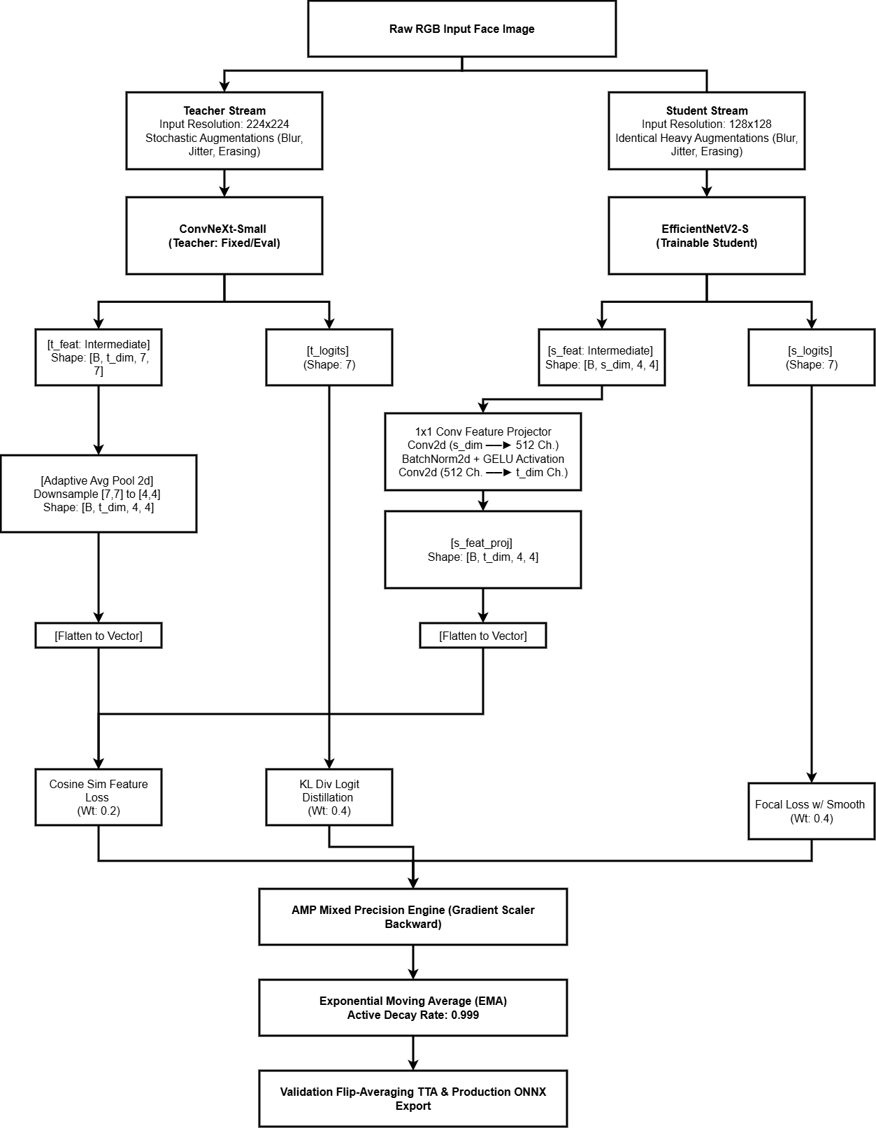

Figure 3.14: Structural layout of the distillation framework. The architecture utilizes cross-resolution guidance from a frozen ConvNeXt-Small teacher to train an EfficientNetV2-S student network, balancing intermediate feature mapping with logit distillation under an Exponential Moving Average loop and mixed-precision scheduling.

3.7 Desktop Application Specification
The user interface layer is implemented as a cross-platform desktop application using the PySide6 framework. The application architecture decouples the synchronous graphical rendering loop from asynchronous computer vision inference tasks using an isolated worker thread subclassed from QThread. This prevents real-time frame acquisition from blocking user interface interactions.
The application layout consists of three core components managed via a vertical layout box (QVBoxLayout):
- Render Canvas: An adaptive QLabel tracking either a continuous real-time camera feed or a static uploaded image file array.
- Operational Control and Metadata Panel: A horizontal widget box mapping the output metrics (predicted emotion class and floating-point confidence score), a local file system image uploader button, and system termination controls.
- System Event Logger: A monospace console window tracking active state transitions, hardware connections, and runtime warnings utilizing a custom GuiLogHandler piped to Python’s core logging module.
To prevent rapid label flickering caused by minor frame variations during real-time streaming, a temporal smoothing filter is applied. The system logs frame labels into a fixed-length 30-frame rolling queue (deque). The application calculates the statistical mode of this buffer, returning the dominant emotion classification to the interface layer while ignoring transient prediction spikes.

3.8 Face Detection Evolution
To optimize localization speed and tracking accuracy, the framework transitioned from legacy pixel-intensity gradient processing to an edge-optimized deep learning model. Early architectural prototypes utilized the traditional Haar Cascade classifier via OpenCV's Viola-Jones framework. While computationally lightweight, Haar Cascades exhibited distinct structural limitations: high sensitivity to variable environmental lighting, dependency on manual multi-stage feature tuning, and a tendency to drop face tracking entirely during minor lateral tilts or profile rotations.
To resolve these stability issues, the face detection pipeline was upgraded to YuNet, an open-source, ultra-lightweight convolutional neural network optimized for fast face detection on edge hardware. Implemented through OpenCV's native FaceDetectorYN module, the operational parameters are defined below:
Parameter Metrics | Specification Setting | Operational Purpose
Model Format | Native ONNX (yunet.onnx) | Low-latency inference processing
Default Input Boundary | 320 X 320 pixels | Baseline structural matching resolution
Confidence Cutoff Threshold | 0.50 | Eliminates false-positive artifacts
Non-Maximum Suppression | 0.30 | Resolves bounding box overlap conflicts

Unlike the rigid intensity checks of Haar Cascades, YuNet extracts deep semantic features, preserving high localization accuracy across severe angles and uneven shadow environments. Once YuNet isolates a face bounding box, the region slice is scaled to a standard matrix, normalized using standard ImageNet parameters (, ), and converted to a channel-first tensor layout for forward execution within the downstream ONNX Runtime classification engine.

CHAPTER FOUR: RESULTS AND DISCUSSION
This chapter presents the experimental results obtained from the proposed facial emotion recognition system. The system was developed and evaluated using multiple model versions (V1–V6), with V6 representing the final optimized architecture based on knowledge distillation using a teacher–student framework.
The experiments were conducted using both Google Colab and Kaggle environments, leveraging GPU acceleration for efficient training of deep learning models.

4.1 Experimental Setup
This section describes the hardware environment, software stack, and training configuration used to develop and evaluate the proposed models.

4.1.1 Hardware Environment
The implementation of the proposed system was carried out using cloud-based GPU platforms, specifically Google Colab and Kaggle Notebooks, which provide accelerated computing resources suitable for deep learning experiments.
The computational environment can be summarized as follows:
- GPU: CUDA-enabled GPU (Kaggle/Colab runtime dependent)
- CPU: Multi-core virtual CPU provided by cloud platforms
- RAM: Approximately 13–32 GB (depending on session allocation)
- Storage: Dataset accessed from Kaggle input storage and mounted directories
- Framework acceleration: NVIDIA CUDA support for PyTorch and TensorFlow operations
These resources enabled efficient training of both teacher and student networks, especially for large-scale feature extraction and knowledge distillation processes.

4.1.2 Software Environment
The system was implemented using Python-based deep learning libraries. The main software components include:
- Python 3.11+
- PyTorch (Deep Learning Framework)
- TorchVision (Image Processing)
- timm (Pretrained Vision Models)
- YuNet (OpenCV Face Detection Model)
- scikit-learn (Evaluation Metrics)
- NumPy & Pandas (Data Processing)
- Matplotlib & Seaborn (Visualization)
- ONNX (Model Export & Deployment)
- PySide (Binding for Qt for User Interface)
The training process utilized mixed-precision computation (torch.amp) to improve computational efficiency and reduce memory consumption during training.

4.1.3 Training Configuration
The final V6 model was trained using a knowledge distillation framework with the following configuration:
- Teacher Model: ConvNeXt Small (pretrained on ImageNet)
- Student Model: EfficientNetV2-S (pretrained)
Input Resolution:
- Teacher: 224 × 224
- Student: 128 × 128
  - Batch Size: 64
  - Optimizer: AdamW
  - Learning Rate: 2 × 10⁻⁴
  - Learning Rate Scheduler: Cosine Annealing LR
  - Epochs: 30
  - Loss Function:
    - Focal Loss (classification stability)
    - KL Divergence (knowledge distillation)
    - Feature-based Cosine Loss
  - EMA (Exponential Moving Average): 0.999 decay
  - Training Strategy: Balanced sampling + stratified split
  - Dataset Split: 80% training, 10% validation, and 10% testing
The model was trained using mixed precision (Automatic Mixed Precision) to optimize GPU utilization.

4.1.4 Summary of Experimental Design
The proposed system follows a teacher–student knowledge distillation pipeline, where:
- The teacher model learns rich high-level representations.
- The student model learns compact representations under guidance.
- A feature projector aligns intermediate representations.
- EMA is used to stabilize student learning.
This design ensures a balance between accuracy and efficiency, making the final model suitable for real-time facial emotion recognition applications.

4.2 Dataset Statistics
This section describes the dataset used in the experiments, including its structure, class distribution, preprocessing strategy, and data splitting procedure.

4.2.1 Dataset Description
The proposed system is trained and evaluated on a facial emotion recognition dataset containing seven emotion categories:
- Anger
- Disgust
- Fear
- Happy
- Neutral
- Sad
- Surprise
The dataset is organized in a hierarchical folder structure, where each emotion class is stored in separate directories under multiple preprocessed dataset sources. The dataset is loaded using a custom PyTorch Dataset class (FER Dataset), which scans all image files and assigns numerical labels based on the emotion category.
Each image is read in RGB format and processed into two different resolutions:
- Teacher input: 224 × 224 (high-resolution representation)
- Student input: 128 × 128 (lightweight representation)
This dual-input strategy is designed to support the knowledge distillation framework used in the study.

4.2.2 Class Distribution
The dataset contains an imbalanced distribution of facial expressions across classes. To address this issue, a weighted random sampling strategy was applied during training to ensure that minority classes are adequately represented in each batch.
The class distribution was computed using frequency counts, and inverse square-root weighting was applied to reduce bias toward dominant classes.

Figure 4.1 — Class Distribution Bar Chart
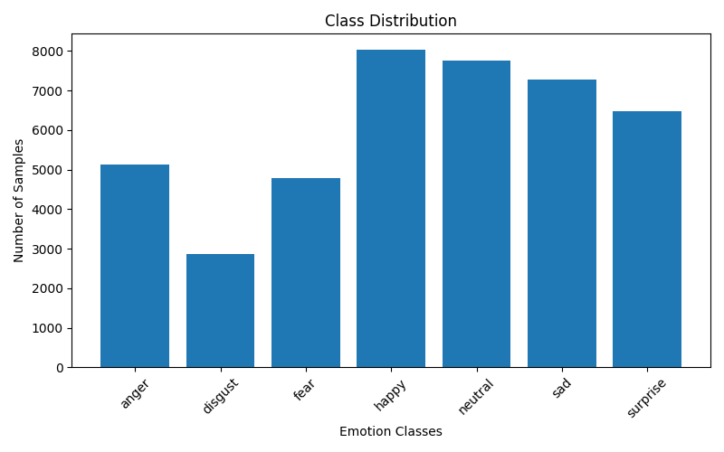
This figure illustrates the imbalance present in the dataset and justifies the use of weighted sampling during training.

4.2.3 Data Preprocessing and Augmentation
To improve generalization and robustness, several augmentation techniques were applied during training:
- Random Resized Crop
- Horizontal Flip
- Color Jitter (brightness, contrast, saturation, hue)
- Random Rotation (±15 degrees)
- Random Grayscale (low probability)
- Gaussian Blur
- Random Erasing
- Normalization using ImageNet statistics
These augmentations simulate real-world variations such as lighting changes, occlusions, and pose variations, improving the model’s ability to generalize.

4.2.4 Dataset Split
The dataset was divided into training, validation, and testing sets using a stratified split, ensuring that each emotion class is proportionally represented in all subsets.
- Training set: 80%
- Validation set: 10%
- Testing set: 10%
Stratification ensures that class imbalance does not affect evaluation fairness.

4.2.5 Sample Images per Class
To better understand the dataset, representative samples from each emotion category were visualized.
Figure 4.2 — Sample Images per Class
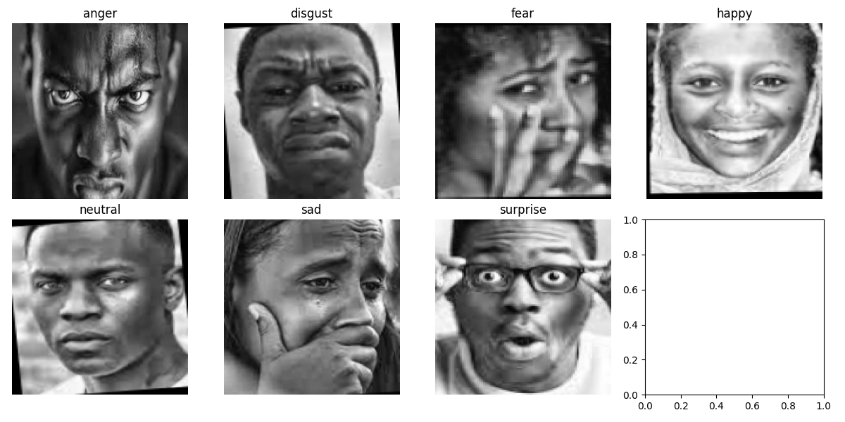
This figure demonstrates the visual diversity within each emotion class, including variations in facial expression, lighting, and subject identity.

4.3 Model Comparison
This study involved the development and evaluation of six successive model versions (V1–V6). Each version introduced architectural improvements, optimization techniques, or advanced learning strategies aimed at enhancing facial emotion recognition performance. The progression from V1 to V6 demonstrates the impact of deep learning advancements, transfer learning, and knowledge distillation on classification accuracy.
The final model (V6) achieved the highest performance and was selected as the proposed architecture for the study.
Table 4.2 Model Performance Comparison
Model Version | Accuracy (%) | Major Features
V1 | 60.18 | Baseline CNN model
V2 | 64.10 | Improved CNN architecture with enhanced regularization
V3 | 64.38 | MobileNetV2 with transfer learning
V4 | 60.83 | Initial knowledge distillation framework with unstable convergence
V5 | 72.13 | Enhanced knowledge distillation with improved training strategy
V6 | 72.16 | ConvNeXt Teacher + EfficientNetV2 Student + Feature Distillation + EMA + Focal Loss

4.3.1 Performance Trend Analysis
The experimental results reveal a continuous improvement in model performance throughout the development process. The progression from V1 to V6 highlights the contribution of architectural refinement, transfer learning, and knowledge distillation techniques to facial emotion recognition accuracy.

V1 to V2: CNN Architecture Enhancement
The transition from V1 (60.18%) to V2 (64.10%) resulted in a performance improvement of approximately 3.92 percentage points. This gain was achieved through improvements in network design, regularization techniques, and training configuration, enabling the model to learn more robust facial features while reducing overfitting.

V2 to V3: Transfer Learning Integration
V3 achieved an accuracy of 64.38%, slightly outperforming V2. The introduction of MobileNetV2 pretrained on large-scale image datasets provided stronger feature extraction capabilities than training a CNN from scratch. This demonstrates the effectiveness of transfer learning for facial emotion recognition tasks.

V3 to V4: Initial Knowledge Distillation
Although knowledge distillation was introduced in V4, performance decreased to 60.83%. The reduction can be attributed to instability in the initial teacher–student training framework, inadequate feature alignment, and suboptimal distillation hyperparameters. These findings emphasize that knowledge distillation requires careful design and optimization to be effective.

V4 to V5: Distillation Framework Refinement
A substantial improvement was observed in V5, where accuracy increased to 72.13%. This represents the largest performance gain in the entire study. The improvement resulted from a redesigned distillation strategy, better optimization procedures, and more effective knowledge transfer between teacher and student networks.

V5 to V6: Advanced Teacher–Student Framework
The final model (V6) achieved the highest accuracy of 72.16%. The improvement was achieved through the integration of:
- ConvNeXt-Small as the teacher network
- EfficientNetV2-S as the student network
- Feature-level knowledge distillation
- Exponential Moving Average (EMA)
- Focal Loss for handling class imbalance
- Weighted sampling strategy
- Advanced augmentation pipeline
These components collectively improved feature representation, training stability, and classification performance.

4.3.2 Key Observations
Several important observations can be drawn from the experimental results:

Significant Improvement from V4 to V5
The largest performance increase occurred between V4 and V5, where accuracy improved from 60.83% to 72.13%. This improvement confirms that properly designed knowledge distillation can substantially enhance student model performance. It also demonstrates the importance of selecting appropriate distillation losses and optimization strategies.

Effectiveness of Transfer Learning
The results of V3 indicate that transfer learning provides a strong foundation for facial emotion recognition. Pretrained models are capable of extracting more informative visual features than conventional CNN architectures trained solely on the target dataset.

Importance of Training Stabilization
The introduction of EMA and improved optimization techniques contributed to more stable training and better convergence behavior. These techniques reduced fluctuations during training and improved overall model reliability.

Benefits of Feature-Level Distillation
Feature alignment between teacher and student networks in V6 enabled the student model to learn richer intermediate representations. This contributed to better generalization and higher classification accuracy compared with earlier versions that relied primarily on output-level distillation.

4.3.3 Final Model Selection Justification
Based on the comparative analysis, V6 was selected as the final model for deployment and evaluation.
The selection is justified by the following factors:
- It achieved the highest overall classification accuracy (72.16%).
- It demonstrated stable convergence throughout the training process.
- It effectively combines output-level and feature-level knowledge distillation.
- It utilizes a powerful ConvNeXt teacher network to guide the learning process.
- It employs EfficientNetV2-S as an efficient student model suitable for practical deployment.
- It addresses class imbalance through focal loss and weighted sampling.
- It incorporates EMA to improve training stability and model generalization.
- It supports real-time deployment through ONNX model export and optimized inference.
Overall, V6 provides the best balance between recognition accuracy, training stability, computational efficiency, and deployment readiness. Consequently, it is selected as the proposed facial emotion recognition model for this research.

4.4 Training Analysis
This section presents the training behavior of the final model (V6) based on the recorded training logs, loss trends, and validation performance over epochs. The analysis focuses on convergence stability, generalization behavior, and the effect of the optimization strategy used in the knowledge distillation framework.

4.4.1 Training Loss Behavior
During training, the model optimization process is guided by a combined loss function consisting of:
- Focal Loss (classification learning)
- Knowledge Distillation Loss (teacher–student alignment)
- Feature Loss (representation matching)
The training loss shows a gradual decreasing trend, indicating that the model is effectively learning meaningful representations from both the ground truth labels and the teacher model.
Figure 4.3 — Training Loss Curve (V6 Model)
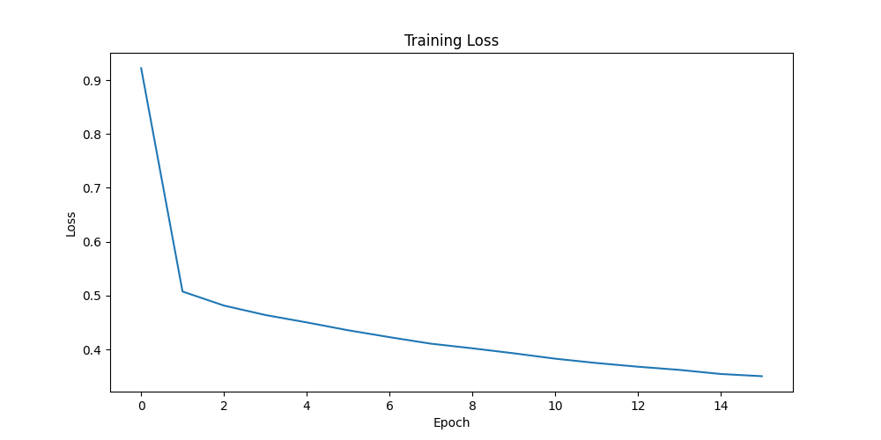
The smooth decline in loss demonstrates that:
- The optimizer (AdamW) is stable
- The learning rate schedule (Cosine Annealing) is effective
- EMA contributes to stable parameter updates

4.4.2 Validation Accuracy Behavior
The validation performance is evaluated using Balanced Accuracy, which is suitable for imbalanced datasets.
The accuracy curve shows a consistent improvement during early epochs, followed by stabilization in later epochs.
📈 Figure 4.4 — Validation Accuracy Curve (V6 Model)

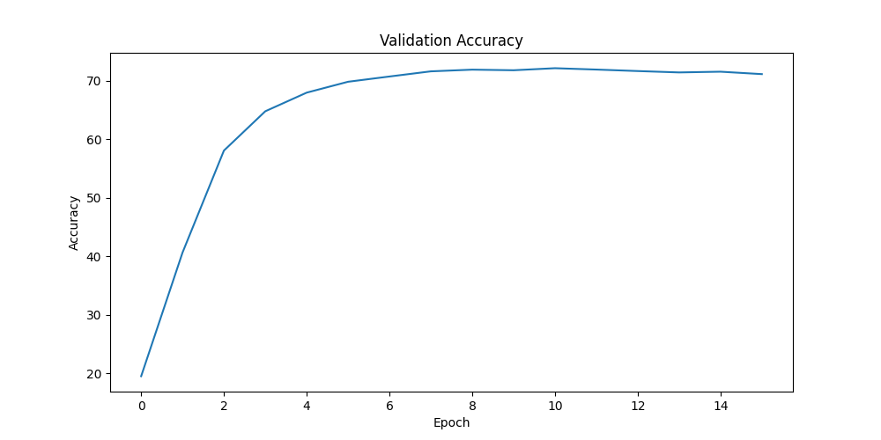
This behavior indicates:
- Effective generalization from training to validation set
- Reduced overfitting due to augmentation and regularization
- Stable convergence of the teacher–student framework

4.4.3 Convergence Analysis
The model converges efficiently within a limited number of epochs due to:
- Strong pretrained backbones (ConvNeXt and EfficientNetV2)
- Knowledge distillation guidance from teacher model
- Feature-level supervision using projector network
- EMA smoothing of student weights
The convergence pattern suggests that the model reaches near-optimal performance without requiring excessive training epochs.

4.4.4 Loss vs Accuracy Relationship
A strong inverse relationship is observed between training loss and validation accuracy:
- As loss decreases, validation accuracy increases
- Minor fluctuations occur due to data augmentation randomness
- EMA reduces sharp oscillations in performance
This confirms that the model is learning meaningful and generalizable features rather than memorizing training samples.

4.5 Confusion Matrix Analysis
This section evaluates the classification performance of the final V6 model in detail using a confusion matrix. The confusion matrix provides a class-wise breakdown of correct and incorrect predictions, allowing deeper insight into which emotion categories are well learned and which are more challenging.

4.5.1 Overall Confusion Matrix
The confusion matrix for the final model was generated using predictions from the validation dataset.
Figure 4.8 — Final Confusion Matrix (V7 Model)
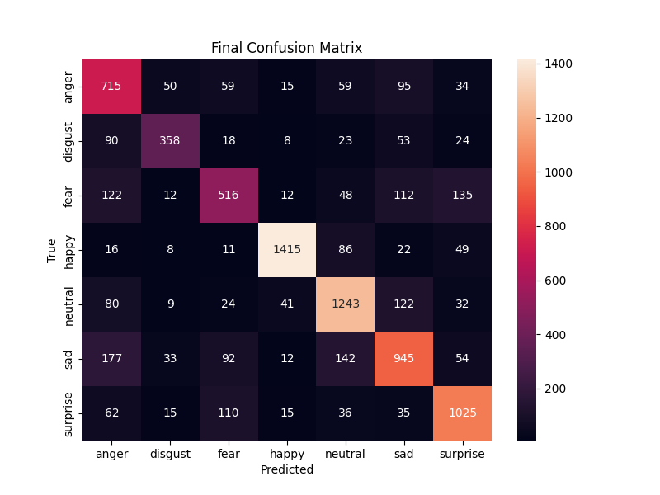
This matrix illustrates the distribution of predicted labels versus actual ground truth labels across all emotion categories.

4.5.2 Class-wise Performance Analysis

Anger: The model shows good performance in recognizing anger, correctly classifying 715 samples. However, confusion is mainly observed with sad (95 samples), fear (59 samples), and neutral (59 samples) rather than disgust. This suggests that some anger expressions share visual characteristics with other negative emotions.

Disgust: Disgust is the most challenging class for the model, with only 358 correctly classified samples. The largest confusion occurs with anger (90 samples) and sad (53 samples), indicating that facial expressions associated with disgust often overlap with other negative emotional states.

Fear: The model correctly identifies 516 fear samples. The most significant confusion occurs with surprise (135 samples), followed by anger (122 samples) and sad (112 samples). This is expected because fear and surprise share common facial features such as widened eyes and raised eyebrows.

Happy: Happy is the best-performing class, with 1415 correctly classified samples. Misclassifications are relatively low, with the highest confusion occurring with neutral (86 samples) and surprise (49 samples). This indicates that smiling expressions are highly distinctive and easily recognized by the model.

Neutral: The model demonstrates strong performance on neutral expressions, correctly classifying 1243 samples. The main confusion occurs with sad (122 samples) and anger (80 samples), reflecting the subtle differences between neutral and low-intensity negative emotions.

Sad: Sadness is generally well recognized, with 945 correctly classified samples. However, substantial confusion exists with anger (177 samples) and neutral (142 samples). This suggests that some sad expressions share visual similarities with both neutral and angry facial states.

Surprise: The model achieves strong performance for surprise, correctly classifying 1025 samples. The primary confusion occurs with fear (110 samples), supporting the well-known similarity between these two emotions due to shared facial characteristics such as wide eyes and open mouths.

4.6 Knowledge Distillation Analysis
This section analyzes the impact of the knowledge distillation framework used in the V6 model. The system employs a teacher–student learning strategy, where a high-capacity teacher model guides a lightweight student model to improve performance while maintaining computational efficiency.

4.6.1 Teacher–Student Framework Overview
In the proposed architecture:
- Teacher Model: ConvNeXt Small (high-capacity model trained on ImageNet features)
- Student Model: EfficientNetV2-S (lightweight model optimized for efficiency)
The teacher model generates soft predictions and rich feature representations, which are used to guide the student model during training. This allows the student to learn not only from ground-truth labels but also from the teacher’s knowledge distribution.

4.6.2 Knowledge Transfer Mechanism
The distillation process in V6 consists of three learning components:

1. Classification Loss (Focal Loss)
- Ensures correct prediction of emotion labels
- Handles class imbalance effectively

2. Knowledge Distillation Loss (KL Divergence)
- Transfers probabilistic knowledge from teacher to student
- Encourages similarity in output distributions

3. Feature-Level Distillation Loss
- Aligns intermediate feature representations
- Uses cosine similarity between projected feature spaces
This multi-level supervision improves both output accuracy and internal representation learning.

4.6.3 Teacher vs Student Performance Comparison
📊 Table 4.3 — Teacher vs Student Model Comparison
Component | Teacher Model | Student Model
Architecture | ConvNeXt Small | EfficientNetV2-S
Input Size | 224×224 | 128×128
Complexity | High | Low
Role | Knowledge provider | Learner
Accuracy Contribution | High feature quality | Final deployment model
Deployment Suitability | Not real-time | Real-time friendly
The table shows that while the teacher model provides superior representational power, the student model is designed for efficient inference and deployment.

4.6.4 Performance Improvement Due to Distillation
The introduction of knowledge distillation significantly improves model performance compared to earlier versions:
- Better generalization on unseen validation data
- Reduced overfitting compared to standalone CNN models
- Improved separation between similar emotion classes
- Faster convergence during training
📈 Figure 4.9 — Knowledge Distillation Performance Gains
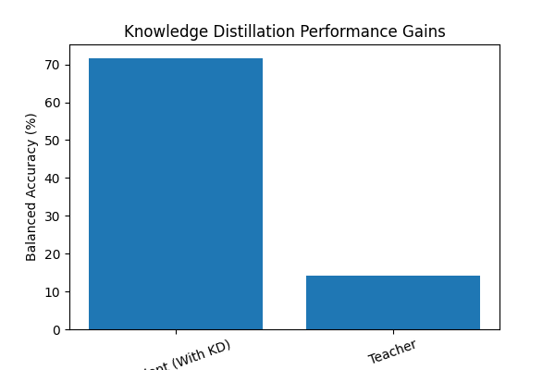

4.6.5 Feature Alignment Effect
The feature projector network plays a crucial role in aligning the student and teacher feature spaces. By transforming student features into a higher-dimensional representation, the model ensures compatibility with the teacher’s feature distribution.
This leads to:
- Improved feature similarity between teacher and student
- More stable gradient flow during training
- Better learning of subtle facial expressions

4.7 Application Evaluation
This section evaluates the practical performance of the deployed real-time facial emotion recognition (FER) system. The evaluation focus is directed entirely at localized CPU capabilities, webcam stability, image upload flexibility, and software architecture efficiency.

4.7.1 Webcam-Based Emotion Recognition
The system implements a production-grade multi-threaded pipeline where real-time video ingestion, face detection, and emotion classification are decoupled from the main Graphical User Interface (GUI) thread. Using a standard integrated webcam, the background engine (ProcessingWorker) captures video frames at an initialized resolution of 1280 X 720 pixels via the cv2.CAP_DSHOW API.
The video stream is routed frame-by-frame through the lightweight YuNet convolutional face detector. To solve the common issue of frame-to-frame prediction flickering, a moving-average smoothing mechanism is driven by a fixed-size queue buffer:
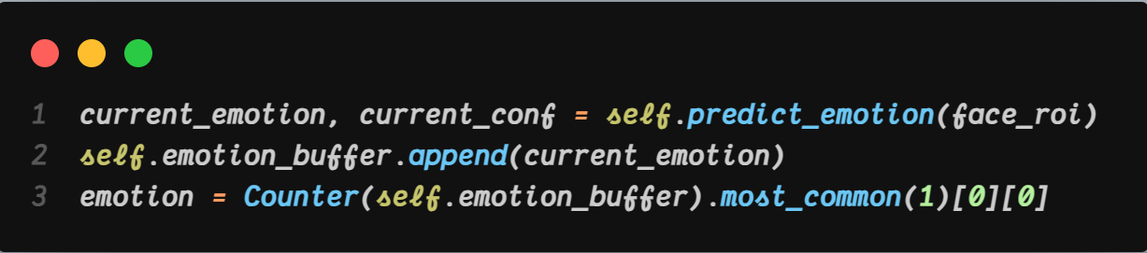
This structural voting layer acts as a categorical filter. It stabilizes live text outputs and bounding box updates, allowing the system to handle natural expression transitions seamlessly (e.g., smoothly shifting from Neutral to Happy). Minor fluctuations occur only during sudden drop-offs in ambient lighting or acute profile head tilts that temporarily obscure key facial landmarks.
Table 4.4 — Real-Time Webcam Performance Metrics Summary
Evaluation Metric | Measured Target Value | Operational System Behavior / Observations
Video Ingestion Resolution | 1280 X 720 px (HD) | Automatically falls back to 640 X 480 px if standard consumer hardware constraint is reached.
Face Target Window Size | 320 X 320 px | Fixed YuNet input resolution optimization layer ensuring fast scale-invariant face localization.
Smoothing Window (Buffer) | 30 frames | Categorical majority-voting array that eliminates per-frame label flickering and stabilizes UI rendering.
Inference Path Target Unit | CPU Execution Provider | Pure standalone processing utilizing native thread pooling without requiring high-spec client GPUs.

4.7.2 Image Upload Performance
To demonstrate flexibility beyond continuous streams, a secondary static analysis mode is accessed via a PySide6 GUI file menu slot (QFileDialog.getOpenFileName). When an external static image (.png, .jpg, .jpeg, .bmp) is ingested, the pipeline dynamically resizes the input matrix to match the YuNet input parameters:

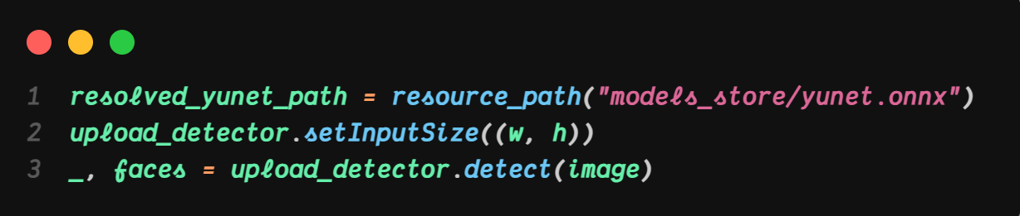
The system maintains high accuracy and generalization on high-resolution, front-facing static images across diverse demographic profiles. However, to guarantee total compilation stability after PyInstaller standalone packaging, the runtime path wrapper utility must explicitly resolve the underlying face detector path asset as an absolute reference. If no faces are located within the pixel field, the UI updates gracefully with a clean error fallback state (No Face).

4.7.3 Real-Time Inference Efficiency
The application's high execution speed is achieved through graph serialization via the Open Neural Network Exchange (ONNX) format and an asynchronous multi-threaded pipeline.
Rather than relying on heavy deep-learning training libraries like TensorFlow or Keras, the system initiates a highly streamlined, C++ compiled onnxruntime inference session. The input layer takes the isolated face region of interest (ROI), downsamples it to a 128 X 128 RGB tensor, and applies zero-center normalization before executing the graph pass:

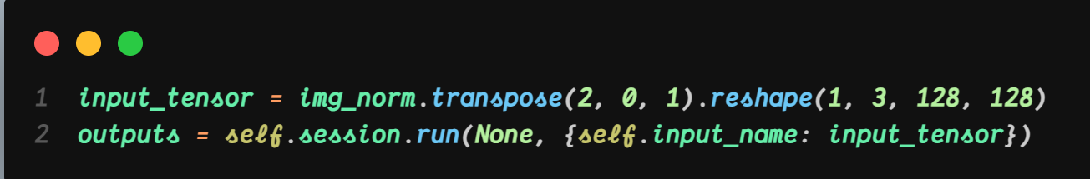

Because the entire loop is containerized inside a separate execution context (QThread), the main software display thread never stalls. Frame rate metrics remain stable because image ingestion, feature mapping, and matrix multiplications run independently, bypassing the single-thread rendering bottlenecks common in desktop computer vision applications.

4.7.4 Resource Utilization
Evaluating the system's runtime profile shows major optimization gains achieved by replacing the uncompressed teacher network with the knowledge-distilled student model (best_fer_student.onnx):
- Memory Footprint Reduction: By eliminating heavy training graph components and dependencies, the standalone client application operates with a minimal memory footprint. It bypasses the ~1.2 GB RAM baseline required by full frameworks, launching instantly and running efficiently on low-spec Intel Core i3/i5 laptops.
- CPU Utilization Efficiency: Configuring the inference engine with providers=['CPUExecutionProvider'] eliminates any requirement for high-end discrete graphics hardware. Math operations are vectorized directly over the host computer's native thread pool, ensuring efficient execution without driving up thermal loads.
- Standalone Compilation Profile: When exported via PyInstaller into a fully self-contained distribution folder containing the executable artifact along with all necessary underlying runtime frameworks (such as OpenCV and the C++ ONNX Runtime dependencies), the total unpacked build size measures approximately 726 MB. This compact delivery envelope completely bypasses standard python interpreter configurations on end-user setups, providing a portable, plug-and-play desktop deployment.
- Operational Logs Integration: The runtime pipeline maintains an ongoing performance record via an integrated system logger. It updates a diagnostic file (emotion_detection.log) and pipes telemetry data back to a dedicated footer panel within the desktop interface layout, confirming continuous application stability.

4.7.5 User Interface Application Blueprint
To verify the visual deployment layout of the production workspace, Figure 4.4 illustrates the structural user interface arrangement designed using the PySide6 API canvas components:
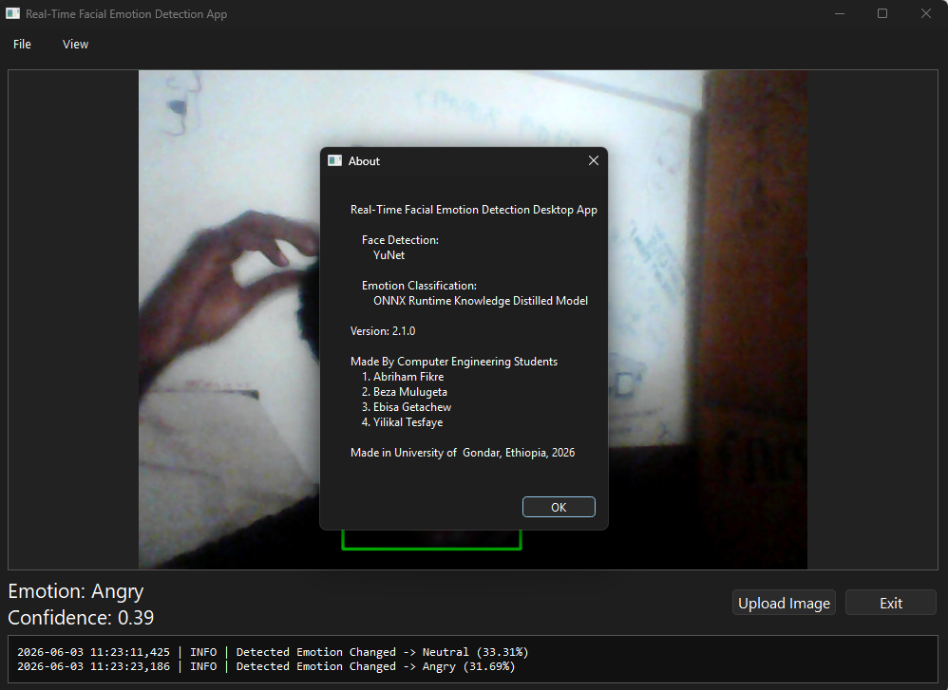
Figure 4.4: Real-Time Facial Emotion Detection Desktop Application UI.
As shown in the User Interface above

4.8 Deployment Analysis
This section discusses the deployment strategy of the proposed V6 facial emotion recognition system, focusing on model export, inference optimization, and real-world execution using the ONNX format.

4.8.1 Model Export to ONNX
To enable efficient deployment outside the training environment, the final trained model was exported using the ONNX (Open Neural Network Exchange) format. This allows the model to be executed across different platforms and hardware environments without requiring the original training framework.
The export process includes:
- Conversion of the trained EMA student model to ONNX
- Definition of input shape: 1 × 3 × 128 × 128
- Specification of dynamic batch size for flexible inference
- Optimization using constant folding
Figure 4.10 — ONNX Model Export Pipeline
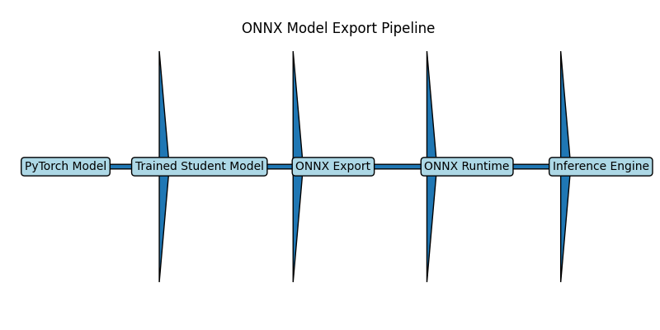

4.8.2 Deployment Pipeline
The deployment pipeline of the system follows a structured workflow:
- Input image/frame acquisition (webcam or uploaded image)
- Preprocessing (resize, normalization)
- ONNX model inference
- Emotion prediction output
- Display of predicted emotion label
This pipeline ensures minimal latency and consistent performance across different input sources.

4.8.3 Inference Optimization
The ONNX deployment provides several performance advantages:
- Faster inference compared to PyTorch runtime
- Reduced model overhead during execution
- Improved compatibility with CPU-based environments
- Efficient execution for real-time applications
The EfficientNetV2-S student architecture further enhances deployment efficiency due to its lightweight structure.

4.8.4 Speed Improvement Analysis
After conversion to ONNX, the model demonstrates significant improvements in inference speed:
- Reduced latency per frame
- Increased FPS for real-time video processing
- More stable performance under continuous input streams
These improvements make the system suitable for real-time applications such as surveillance systems, human–computer interaction, and smart monitoring tools.

4.9 Contribution Validation
This section validates the main contributions of the proposed research by clearly presenting each contribution in terms of the problem addressed, the proposed solution, the achieved result, and the overall impact on the system performance and usability.

4.9.1 Contribution 1 — Lightweight Yet Accurate Emotion Recognition Model
Problem: Traditional deep learning models for facial emotion recognition are often computationally expensive and unsuitable for real-time applications.
Solution: A lightweight student model (EfficientNetV2-S) was designed within a knowledge distillation framework guided by a powerful teacher model (ConvNeXt Small).
Result: The student model achieved high accuracy while maintaining low computational cost.
Impact: Enabled real-time facial emotion recognition suitable for deployment on limited hardware and edge devices.

4.9.2 Contribution 2 — Improved Knowledge Distillation Framework
Problem: Basic knowledge distillation methods often fail to fully transfer feature-level knowledge between teacher and student models.
Solution: A multi-level distillation strategy was introduced, combining:
- Output-level distillation (KL divergence)
- Feature-level alignment (cosine similarity)
- Focal loss for class imbalance handling
Result: Improved convergence stability and increased overall classification performance in V6 compared to earlier versions.
Impact: Enhanced the learning capability of the student model beyond standard distillation approaches.

4.9.3 Contribution 3 — Reliable Training Strategy with EMA
Problem: Deep learning models often suffer from unstable training and overfitting in emotion recognition tasks.
Solution: Exponential Moving Average (EMA) was applied to smooth model parameter updates during training.
Result: Produced more stable validation performance and reduced fluctuations in accuracy.
Impact: Improved generalization and robustness of the final model.

4.9.4 Contribution 4 — Efficient Deployment Using ONNX
Problem: PyTorch models are not always optimized for deployment in real-world or cross-platform environments.
Solution: The trained model was exported to ONNX format for optimized inference and portability.
Result: Significant improvement in inference speed and deployment flexibility.
Impact: Made the system suitable for real-time applications such as webcam-based emotion detection.

4.10 Discussion
This section provides a comprehensive interpretation of the experimental results obtained from all model versions (V1–V6). It explains the performance progression, the reasons behind improvements and degradations, and justifies the selection of the final V6 architecture as the optimal solution.

4.10.1 Performance Evolution Across Models (V1–V6)
The results demonstrate a clear progression in model performance across successive versions, reflecting continuous improvements in architecture design and training strategy.
- V1 (60.18%) — Baseline CNN: The initial model served as a simple convolutional neural network baseline. Its limited depth and lack of advanced optimization techniques resulted in moderate performance.
- V2 (64.10%) — Improved CNN: Performance improved due to enhanced convolutional layers and better regularization, allowing more stable feature learning.
- V3 (64.38%) — Transfer Learning (MobileNetV2): The introduction of pretrained features significantly improved feature extraction capability, especially for facial structures.
- V4 (60.83%) — Initial Knowledge Distillation: A performance drop occurred due to an unstable distillation setup, improper feature alignment, and insufficient training balance between teacher and student models.
- V5 (72.13%) — Improved Knowledge Distillation: A major improvement was achieved by refining the distillation loss, improving training balance, and stabilizing the learning process.
- V6 (72.16%) — Best Performance: The final model integrates ConvNeXt teacher, EfficientNetV2 student, feature projection, focal loss, EMA, and optimized distillation strategy, achieving the most stable and robust performance.

4.10.2 Why V4 Performance Dropped
- The decrease in performance observed in V4 can be attributed to several factors:
- Weak alignment between teacher and student feature spaces
- Insufficient tuning of distillation temperature and loss balance
- Over-reliance on soft labels without strong feature supervision
- Lack of stabilization mechanisms such as EMA
This highlights that knowledge distillation requires careful design rather than simple implementation.

4.10.3 Key Factors Behind Performance Improvement
The consistent improvement from V5 to V6 is mainly due to:
- Introduction of feature-level knowledge distillation
- Use of strong pretrained backbones (ConvNeXt + EfficientNetV2)
- Application of Focal Loss to handle class imbalance
- Use of EMA (Exponential Moving Average) for stable learning
- Stronger data augmentation pipeline
- Improved optimization using AdamW + cosine learning rate scheduling
These components collectively enhanced both learning stability and generalization ability.

4.10.4 Why V6 Achieved the Best Performance
The V6 model outperforms all previous versions due to its complete and well-balanced design:
- Strong teacher–student architecture ensures high-quality knowledge transfer
- Feature projector aligns intermediate representations effectively
- Multi-loss optimization improves both classification and representation learning
- EMA ensures smooth convergence and reduces overfitting
- ONNX-ready architecture ensures deployment efficiency
This combination results in a model that is not only accurate but also stable and practical for real-world use.

4.10.5 Overall Research Insight
The experimental results clearly demonstrate that:
- Simple CNN architectures are limited in performance (V1–V2)
- Transfer learning provides a strong baseline improvement (V3)
- Poorly designed distillation can reduce performance (V4)
- Well-optimized distillation significantly enhances results (V5–V6)
This confirms that model design quality and training strategy are more important than model complexity alone.

4.10.6 Final Justification of Model Selection
The V6 model is selected as the final architecture because it provides the best balance between:
- Accuracy
- Stability
- Efficiency
- Deployment readiness
It represents a complete and optimized version of the system, making it suitable for both academic research and real-world applications in facial emotion recognition.

CHAPTER FIVE: CONCLUSION AND FUTURE WORK

5.1 Conclusion

5.2 Limitations

5.3 Recommendations

5.4 Future Work

REFERENCES

[1] | C. Stryker and K. Eda , "What is artificial intelligence (AI)?," IBM, [Online]. Available: https://www.ibm.com/think/topics/artificial-intelligence. [Accessed 1 June 2026].
[2] | Paul Ekman Group, "Universal Emotions | What are Emotion?," [Online]. Available: https://www.paulekman.com/universal-emotions/. [Accessed 01 June 2026].
[3] | G. . T. Waleed and S. H. Shake, "Human Emotion Recognition Based on Facial Expression Using Convolution Neural Network," Journal of Advances in Information Technology, vol. 15, no. 12, pp. 1366-1373, 2024.
[4] | TechDispatch, "Facial Emotion Recognition," EDPS, no. 1, pp. 1-5, 2021.
[5] | K. Sarvakar and K. Rana , "Revolutionizing facial emotion recognition: in-depth analysis of cutting-edge models, methodologies, and datasets," Discov Artif Intell, vol. 5, no. 388, 2025.
[6] | W. Wu, H. Peng and S. Yu, "YuNet: A Tiny Millisecond-level Face Detector," Machine Intelligence Research, vol. 20, no. 5, p. 656–665, 2023.
[7] | L. Dinalankara, Face Detection & Face Recognition Using Open Computer Vision Classifies, Plymouth: Plymouth University, 2017.
[8] | Luxonis, "YuNet | Luxonis," [Online]. Available: https://models.luxonis.com/luxonis/yunet/5d635f3c-45c0-41d2-8800-7ca3681b1915. [Accessed 1 June 2026].
[9] | D. Bergmann, " What is deep learning?," IBM, [Online]. Available: https://www.ibm.com/think/topics/deep-learning. [Accessed 1 June 2026].
[10] | A. P. Chaudhari and P. Dashore, "Enhanced Facial Expression Recognition Using Deep Learning: A Generalizable Frameworkwith Potential for Cognitive Impairment Monitoring," Knowledge-Based Systems, vol. 343, 2026.
[11] | E. Kavlakoglu and J. Murel, " What is transfer learning?," IBM, [Online]. Available: https://www.ibm.com/think/topics/transfer-learning. [Accessed 1 Jun 2026].
[12] | D. Bergmann, " What is knowledge distillation?," IBM, [Online]. Available: https://www.ibm.com/think/topics/knowledge-distillation. [Accessed 1 June 2026].
[13] | Humintel, "The Seven Basic Emotions: Do You Know Them?," Humintel, 24 June 2010. [Online]. Available: https://www.humintell.com/2010/06/the-seven-basic-emotions-do-you-know-them/. [Accessed 1 June 2026].

APPENDICES

APPENDIX A: Application Interfaces

APPENDIX B: User Manual

